

**The Shop Nest Store Capstone Project**

Kshitiz Prasad

23rd June, 2024

Shop Nest stands as the leading department store in the e-commerce marketplaces in Portugal. Serving as a seamless link, it connects small businesses from various regions in Portugal to channels, streamlining the process with a single point of contact. Through the Shop Nest Store, these merchants can showcase and sell their products, with the added convenience of direct shipment to customers facilitated by Shop Nest logistics partners. The provided data represents authentic commercial information that has undergone the process of anonymization.

**1. Top Categories by Total Sales**

**Question Statement:**

 Identify and visually represent the top 10 product categories by total sales.

**Data Overview:**

The dataset includes sales data for various product categories, detailing the product category and the sales amount for each transaction.

**Analysis Approach:**

Sales data is aggregated by product category, and the total sales amount for each category is calculated. The categories are then ranked by sales volume, with the top 10 highest-selling categories selected for detailed analysis and visualization.

**Findings:**

The top 10 categories by total sales are:

- Auto

- Garden Tools

- Health & Beauty

- Cool Stuff

- Housewares

- Computers & Accessories

- Bed Bath & Table

- Sports & Leisure

- Watches & Gifts

- Furniture Decor

 These categories significantly outperform others, reflecting strong consumer demand. Categories like Auto, Garden Tools, and Health & Beauty are particularly noteworthy for their consistent high sales.

**Insights:**

- Categories such as Cool Stuff, Computers & Accessories, and Watches & Gifts cover a wide range of products, appealing to varied consumer interests.

- Household and recreational products (Housewares, Bed Bath & Table, and Sports & Leisure) are key drivers of overall sales.

**Visual Representation:**

A horizontal bar chart is used to depict the top 10 product categories by total sales, where each bar's length correlates with the total sales amount, illustrating their dominance.

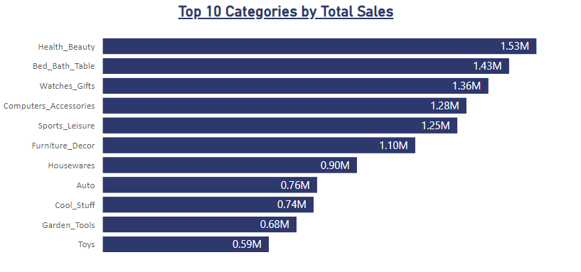

**Conclusion and Recommendations:**

Understanding top-performing categories offers insights into consumer preferences and market trends. Businesses should focus on optimizing strategies for these high-performing categories, explore cross-selling opportunities, and continuously monitor sales trends for adaptive strategies.

**2. Delayed Orders Analysis:**

**Question Statement:**

Determine the number of delayed orders in each category. An order is considered delayed if the actual delivery date is later than the estimated delivery date.

**Data Overview:**

The dataset includes order information such as order IDs, delivery dates, estimated delivery dates, product categories, and delivery statuses.

**Analysis Approach:**

Delay duration is calculated by subtracting the estimated delivery date from the actual delivery date. Orders with a delay duration greater than zero are flagged as delayed.

Alternately, we here have used, if the estimated delivery time is greater than actual delivery time then the delivery is considered to be as on-time, and otherwise delayed.

Moreover, there are some blank c cells in the data set for the column of actual delivery date which states that the delivery for some reason didn’t took place so for these delivery items we have considered them as undelivered items, and for those which are not blank we’ve followed the above-mentioned criteria.

The total number of delayed orders is then aggregated by category.

**Visualization:**

Vertical bars are representing the delayed product categories codes, these codes were manually created, first 2 letters are the first two characters from the product name in English then comes the numeric part stating the length of the product category name in English then for the last 2 letters are the ending 2 characters from the product category name. And these codes are lying on the x axis, whereas on the y axis are the count of delayed orders.

Visualized through a bar chart, each bar represents a product category with the bar height corresponding to the number of delayed orders.

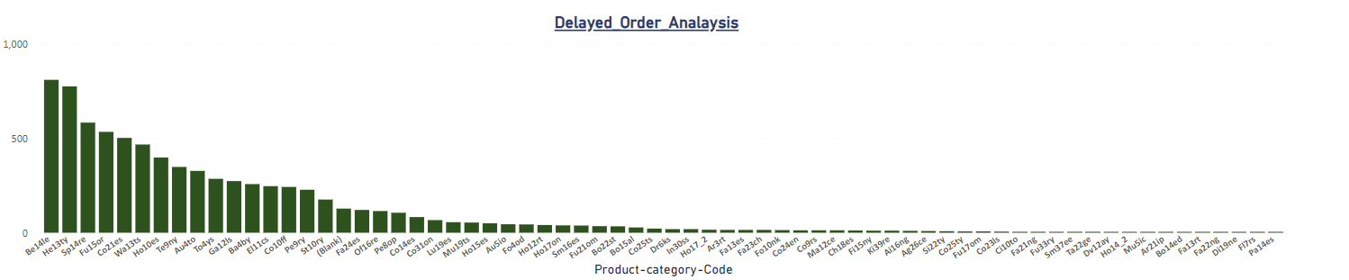

**Recommendations:**

Businesses should prioritize addressing delays in categories with the highest number of delays by optimizing transportation routes, enhancing supplier communication, and investing in tracking technologies.

**3. Monthly Comparison of Delayed and On-Time Orders:**

**Question Statement:**

Create a dynamic visual that compares the number of delayed orders to the number of orders received earlier for each month. Utilize the drill through cross-report feature to provide a detailed analysis of late and on-time deliveries.

**Visualization:**

Below line graph is depicting the delayed orders’ comparison with the on-time delivered orders month wise. On the x-axis are the months differentiated by the markers on the line and count of orders delayed or on – time are represented on the y-axis.

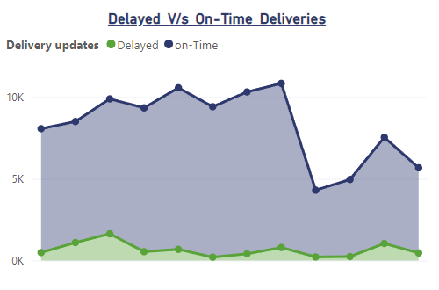

**Findings:**

- June: Lowest delayed orders 204, indicating high operational efficiency.

Followed by September (217) and October (240) respectively.

- August: Highest on-time orders (10044) despite high order volume, suggesting effective logistics management.

Followed by July (9909) and May (9889) respectively.

**Recommendations:**

- Replicate best practices from June to maintain or improve delivery performance.

- Analyze August’s success factors to replicate effective strategies in future operations.

- Continuously monitor monthly performance to identify and act on improvement opportunities.

**4. Payment Method Analysis:**

**Question Statement:**

Analyze the most frequently used payment methods by customers using a visually appealing representation, such as a pie chart or other suitable visuals.

**Data Overview:**

 The dataset includes transaction data specifying payment methods i.e. credit card, debit card, boleto, voucher and undefined.

**Findings and Insights:**

- Credit Card: Most frequently used, indicating a strong customer preference.

- Boleto : Can be considered as the second most used mode of payment after credit cards.

- Voucher: Followed by Credit card and boleto is Voucher with the holdings of 3.8%

- Debit Card: Used less frequently but still significant.

- Other Methods: Include cash, mobile payments, contributing to remaining transactions.

**Recommendations:**

Businesses should prioritize credit card processing while offering diverse payment options to cater to different preferences. Regularly monitor payment trends and feedback to optimize payment systems.

**Visual Representation:**

A pie chart depicts the distribution of payment methods, highlighting the dominance of credit card payments.

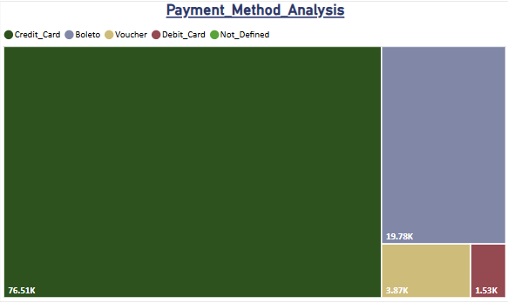

**5. Product Rating Analysis:**

**Question Statement**

Determine the top 10 highest-rated products and the bottom 10 lowest-rated products using a bar or column chart.

**Visual Representation:**

Here the analysis can be insighted by two horizontal bar charts representing least and most rated product categories. Product categories can be seen on the Y-axis whereas the average ratings can be seen on the x-axis.

Each bar has the data labels inside the end of themselves that shows the overall average review scores.

**Insights:**

- High Ratings: Reflect superior quality and customer satisfaction.

- Low Ratings: Indicate issues needing resolution, such as quality or functionality improvements.

Here we can see the products that needs the resolution most are those which falls under the “least rated products” whereas those products which reflect the superior quality and customer satisfaction are those which can be seen in the ‘most rated products.

**Recommendations:**

Promote top-rated products and address deficiencies in low-rated products through targeted improvement initiatives.

**6. State-wise Sales Analysis:**

**Question Statement:**

Identify and visually represent states with high and low sales, providing a clear understanding of regional sales performance.

**Findings:**

- SP State shows consistently high sales, crucial for overall performance.

- States Like AM, AC, AP, RR are some of the states that are really doing worst and need some kind of attention as well as more attention or probably the functions shall be evoked from these states as to save the higher cost that are incurred to provide the products in these states.

- Regional Disparities: Significant variations in sales across states can be seen, as states like SP being exceptionally good, RJ, MG, RS, PR, BA are doing well in terms of revenues whereas states like, AM, AC, AP, RR are performing exactly the opposite hence creating the disparities.

**Recommendations:**

- Invest further in high-performing regions.

- Investigate and enhance strategies in low-performing regions to boost sales.

**Visualization:**

The Ribbon chart depicts the above-mentioned data in the graph form, where on the x-axis we can witness the states and on the other hand on y-axis we can witness the total revenues.

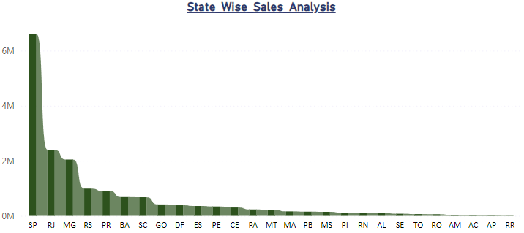

**7. Seasonal Sales Patterns:**

**Question Statement**

Investigate and visualize any seasonal patterns (Quarterly) or trends in sales data over the course of the year.

**Findings:**

- Quarter 2: Consistently highest sales, likely due to holidays and promotional events.

- Quarterly Variations: Other quarters exhibit moderate fluctuations.

**Recommendations:**

Capitalize on Quarter 2 peak demand through strategic planning and resource allocation. Continuously monitor and adapt to seasonal sales trends.

**Visualization:**

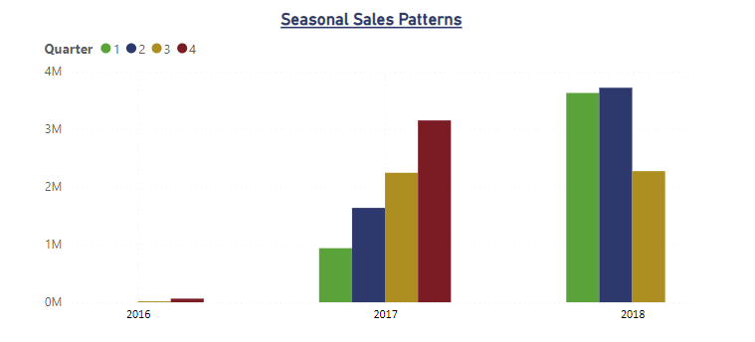

**8. Revenue Analysis:**

**Question Statement:**

 Determine the total revenue generated by Shop Nest Store and analyze how it changes over time (Yearly). Represent this information through suitable visuals to highlight trends and patterns.

**Findings:**

- Total Revenue Trend: Shows overall performance and growth trajectory.

- Seasonal Variations: Reflect influences such as holidays and promotions.

**Insights and Recommendations:**

Understanding revenue trends helps identify growth opportunities and informs strategic decisions in product offerings and marketing. Regularly monitor revenue and adjust strategies to sustain growth. Future analyses should consider additional factors influencing revenue, like pricing strategies and market dynamics.

**Visualization:**

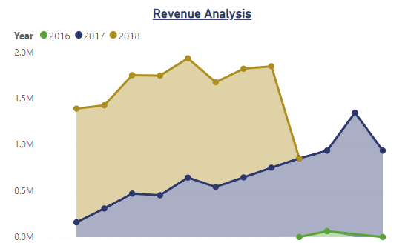

**CONCLUSION**

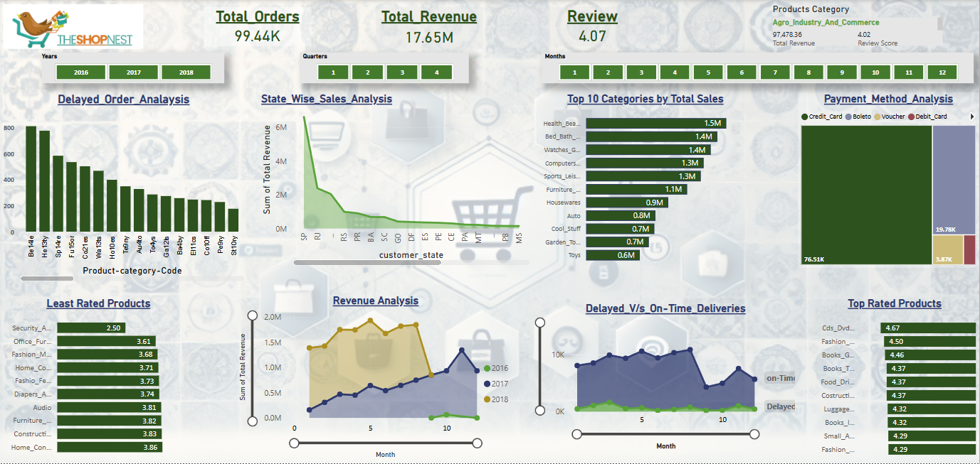

The comprehensive analyses conducted for Shop Nest Store reveal critical insights into various aspects of its operations, from top-selling product categories and delayed order patterns to payment method preferences and regional sales performance. By examining these facets, ShopNest can strategically enhance its business operations and improve overall customer satisfaction.

**Key Findings and Recommendations:**

1. **Top Categories by Total Price:**

* **Findings:** Categories like Auto, Garden Tools, and Health & Beauty exhibit the highest sales.
* **Recommendations:** Focus on optimizing inventory, marketing efforts, and product assortment for these top-performing categories. Consider cross-selling and upselling strategies within these high-demand areas.

1. **Delayed Orders Analysis:**

* **Findings:** Identified categories with high numbers of delayed orders.
* **Recommendations:** Implement measures to enhance delivery processes in these categories, such as optimizing transportation routes and improving supplier communication.

1. **Monthly Comparison of Delayed and On-Time Orders:**

* **Findings:** July shows the lowest number of delayed orders, while August has the highest number of on-time orders.
* **Recommendations:** Leverage best practices from July to maintain delivery efficiency. Analyze August's performance to replicate successful strategies.

1. **Payment Method Analysis:**

* **Findings:** Credit cards are the most frequently used payment method.
* **Recommendations:** Ensure robust credit card processing systems while offering a variety of payment options to cater to diverse customer preferences.

1. **Product Rating Analysis:**

* **Findings:** Identified the top 10 highest-rated and bottom 10 lowest-rated products.
* **Recommendations:** Promote top-rated products and implement improvement initiatives for low-rated products to enhance overall customer satisfaction.

1. **State-wise Sales Analysis:**

* **Findings:** SP state generates the highest sales orders.
* **Recommendations:** Allocate more resources to high-performing regions and develop tailored strategies to boost sales in underperforming states.

1. **Seasonal Sales Patterns:**

* **Findings:** Quarter 2 consistently shows the highest sales volume.
* **Recommendations:** Plan marketing campaigns and inventory management around peak sales periods to maximize revenue.

1. **Revenue Analysis:**

* **Findings:** Analysis shows trends in revenue generation over time, indicating overall growth and seasonal fluctuations.
* **Recommendations:** Regularly monitor revenue trends, identify growth opportunities, and adjust strategies to enhance long-term performance.

**Strategic Implications:**

* **Resource Allocation:** Prioritize resources towards high-performing categories and regions while addressing areas needing improvement.
* **Process Optimization:** Implement continuous improvements in delivery processes, inventory management, and customer service based on data insights.
* **Market Adaptation:** Stay agile in response to market trends, consumer behavior, and seasonal variations to maintain a competitive edge.

**Future Considerations:**

* **In-depth Analysis:** Further explore underlying factors influencing sales performance, such as demographic trends, pricing strategies, and competitive dynamics.
* **Technological Integration:** Invest in technology solutions for better tracking, data analysis, and customer relationship management to stay ahead of market changes.
* **Customer Feedback:** Continuously gather and analyze customer feedback to inform product development and service enhancement initiatives.

By leveraging these insights, Shop Nest Store can refine its strategic planning, optimize operations, and drive sustainable growth, ensuring continued success in the competitive e-commerce landscape.